Input data:

1. There is Ingot Casting Line (ICL), Line Control System (LCS), Information Transfer System (ITS).
2. There are two furnaces in a single complex with ICL, let there be number 7 and 8.
3. Metal is prepared in the furnace for casting (weight of metal in furnace is 60 t).
4. For each batch of metal to be prepared in the furnace for casting there is a document so called CASTING PLAN. The information about CASTING PLANS is stored in ITS. CASTING PLAN has a combined number: number of furnace and sequence number from 1 to 9999, for example: 02 0026. Such combined number is not unique, it repeats for each furnace in every 10000 documents. CASTING PLAN also has UNIQUE IDENTIFICATOR (melt_id).

When metal is ready to be cast the CASTING PLAN gets the status READY TO CAST. Any furnace in any time has only one CASTING PLAN document with READY TO CAST status.

1. ICL produces the finished product, the unit of the product is a stack (set of ingots). Each stack shall be identified either for electronic data register and exchange or for visual display (sticker on a stack with visual information.
2. LCS shall query the data set from ITS for identification of finished product. For query from LCS to ITS it is enough to inform the number of casting line. ITS will send back the data set to LCS for casting line furnaces.

|  |  |  |
| --- | --- | --- |
| Parameter | Type of data | Length |
| Number of line | Integer (int) | 1 |

1. ITS will get back the data set to ITS

|  |  |  |  |
| --- | --- | --- | --- |
| № | Parameter | Type of data | Length |
| 1 | Number of furnace | Integer (int) | 2 |
| 2 | Number of melt | Integer (int) | 4 |
| 3 | CASTING PLAN unique number (melt_id) | Integer (int) | 9 |
| 4 | Name of product | Character (char) | 40 |

ITS will get back the empty data set if there are no CASTING PLANS READY TO CAST (i.e. no ready portion of metal in the furnace). For the case of fault (loss of communication) it is required to provide possibility for the operator to input the above mentioned parameters to LCS manually. At that melt_id = 0. When the data for each unit of finished product is received from LCS with melt_id = 0, then ITS will identify the stack based on the furnace number and melt number.

1. For data transfer for each unit of finished product (stack) from LCS to IT’S THE following set of data shall be transferred:

|  |  |  |  |
| --- | --- | --- | --- |
| № | Parameter | Type of data | Length |
| 1 | CASTING PLAN unique number (melt_id) | Integer (int) | 9 |
| 2 | Number of furnace | Integer (int) | 2 |
| 3 | Number of melt | Integer (int) | 4 |
| 4 | Stack sequence number | Integer (int) | 3 |
| 5 | Weight | Integer (int) | 4 |

1. For visualization the following information is used:

* Sticker on a stack:

Number of furnace (1), number of melt (2), name of product (5), number of stack (3), weight of stack (4) and barcode.

* 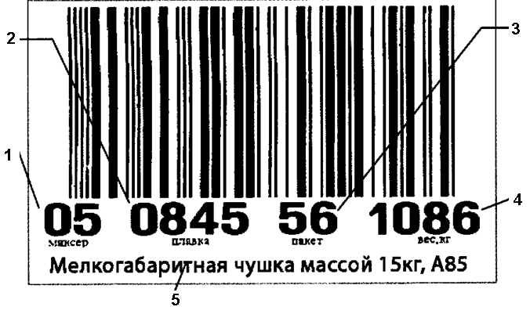stamp on INGOT:

Number of furnace (1), number of melt (2).

1. Barcode creation rule: ABBBBBBBBBCCCx:

A – 1 or 5 (5 – to mark the rejected products)

BBBBBBBBB – CASTING PLAN unique number – melt_id transmitted from ITS and extended on the LEFT SIDE by zeroes up to 9 symbols, CCC – the sequence number of stack (inside this melt cycle), extended on the LEFT SIDE by zeroes up to 3 symbols.

Х – check figure as per GOST R 51001-96 (EN-8001)

**SPECIAL ATTENTION – previously (in document 07147-SLSr1) the extension on the RIGHT SIDE was specified – that is wrong, for example: adding zeroes on the RIGHT to 1 and 10 we get the same figure 100 и 100, adding on the LEFT SIDE to 1 and to 10 we get different figures 001 and 010.**

1. Question – can we get another image template on stickers? For example instead of EAN-13? Is it possible to UPLOAD the templates for creation of print content to the sticker printer, for example instead of the sequence MM_CCCC_РР_WWWW (ММ-furnace, СССС-melt, РР-stack, WWWW- weight) to print another sequence or text?
2. Also it is required to take melt parameters data (speed of melt, selected recipe of melt etc.) and furnaces parameters (temperature etc.) to ITS.

Communication protocol

Which protocol and interface will be used for exchange the information between LCS and ITS?

Interfaces in an order of preference:

1. OPC with «Kepware» software products applications
2. DBMS of SQL/92 standard and higher
3. Direct interface with controllers (PLC) with application of «Kepware» software.

(<http://www.kepware.com/>)